Ministry of Education and Science of Ukraine

Department of Science and Education of Kharkiv Regional State Administration

Municipal institution "Kharkiv Regional Small Academy of Sciences

Kharkiv Regional Council "

Department computer science

Section: Internet-technologies and WEB-design

**INDOOR AIR QUALITY MONITORING SYSTEM**

The work was performed by:

**Mitin Valentin Vitalievich**, a student of the 11th grade of the Kharkiv educational complex № 45 "Academic Gymnasium" of the Kharkiv City Council

Kharkiv region

Supervisor:

**Rukkas Kirilo Markovic**, Professor of the Department of Theoretical and Applied Informatics, Faculty of Mechanics and Mathematics, VNKarazin Kharkiv National University, Associate Professor, Doctor of Technical Sciences

Kharkiv - 2021

**SUMMARY**

**INDOOR AIR QUALITY MONITORING SYSTEM**

**Mitin Valentin Vitalievich**; Kharkiv Territorial Branch of the Academy of Sciences of Ukraine; Municipal Institution "Kharkiv Regional Small Academy of Sciences of the Kharkiv Regional Council"; Kharkiv educational complex № 45 "Academic gymnasium" of Kharkiv city council of Kharkiv region; Grade 11; Kharkiv;

**Rukkas Kirilo Markovic**, Professor of the Department of Theoretical and Applied Informatics, Faculty of Mechanics and Mathematics, Kharkiv National University. V.N. Karazina, associate professor, doctor of technical sciences

The current state of atmospheric air is accompanied by a change in its natural composition, in particular, an increase in the amount of carbon dioxide (CO2). The growing number of air pollutants poses a threat not only to the environment but also to human health. The criterion for air quality is the maximum permissible concentrations of harmful substances or approximate safe levels of exposure. In this regard, more relevant is the development of air quality measuring devices that allow you to monitor data for transmission to the end user.

The purpose of the study is to ensure the collection of data on indoor air quality. To achieve this goal, an air quality measuring device and a program for taking parameters from the sensor were developed, as well as 2 programs for communication with the chatbot user in the Telegram and the Web-page. All of these programs make up the air quality monitoring system described in this explanatory note.

A thorough analysis of the most well-known existing monitoring systems was conducted to implement a fundamentally new system that has more advantages over older counterparts than disadvantages.

In practice, the system can be used to warn the user of the device in advance about polluted air in the room where he placed the device, to prevent serious health consequences.

**Keywords:** chat bot, monitoring system, volatile organic compounds, VOC, CO2, air quality.

**CONTENT**

INTRODUCTION ……………………………………………………………………………… ..4

SECTION 1. ANALYSIS OF EXISTING MONITORING SYSTEMS ............................... 7

SECTION 2. SELECTION OF HARDWARE FOR PROJECT IMPLEMENTATION AND ALGORITHM OF SYSTEM OPERATION ..................................... .......... 11

2.1. Scheme of system operation ............................................... ............................... 11

2.2. Rationale for the choice of sensor …………………………… ... ……… ... 12

2.3. Rationale for the choice of board ………………………. ………………… .15

2.4. Raspberry pi settings for indoor air analysis system …… ...................................... ..............................................… ... .18

2.5. Software on Raspberry pi 21 ... 21

2.6. Software on the main server ……………………… 23

2.7. Development of Telegram-bot ……………………………………………… ... 23

2.8. Development of WEB-page for interaction with the user …………… ..24

2.9. Strategy of frequency of data collection from the sensor and their further sending to the user ....................................... .................................... 27

SECTION 3. EXAMPLES OF USING THE SYSTEM ........................................... 29

3.1. Example of Telegram bot operation ............................................. .................. 29

3.2. Example of WEB-page operation ............................................. ................. 30

CONCLUSIONS ………………………………………………………………………. 35

LIST OF SOURCES USED ………………………………………… 36

**INTRODUCTION**

The current state of atmospheric air is accompanied by a change in its natural composition, in particular, an increase in the amount of carbon dioxide (CO2). According to the Mauna Loa Observatory on May 11, 2019, the level of CO2in the atmosphere reached an unprecedented mark in the history of its measurements - 415.26 ppm [1]. The reason for this is the increase in fossil burning and deforestation of large forests.

October 21, 2019 on Ukraine's air pollution map, which collects data from 11,000 sensors in 90 countries (US Environmental Protection Agency Project), ranked third in terms of air pollution, surpassing India and China [2].

Concentration compounds-air pollutants above the maximum - permissible level poses a threat not only to the environment but also to human health. It should be understood that the concentration of harmful substances in the air and in the indoor air may be different.

In all rooms where people are temporarily or permanently present, the main air pollutant is carbon dioxide (CO2). Normally, this gas is contained in the outdoor air at a concentration of 300-400 ppm (0.03-0.04%), however, with each exhalation a person fills the surrounding air with a new portion of CO2(18-25 liters per hour). Given that the concentration of carbon dioxide in the exhaled air is 100 times higher than in clean air, the room quickly becomes potentially dangerous to health.

Increasing the level of CO2 can cause symptoms of lack of oxygen, deterioration of cognitive abilities, directly affect the ability to work, to its complete loss, which ultimately affects the educational process in schools and the results of companies.

It is also necessary to take into account the many products that emit volatile organic compounds into the air. The concentration of these substances indoors can be even 100 times higher than outside.

Volatile organic compounds or VOC (volatile organic compounds) are chemicals that are released in the form of gases from solids or liquids, easily evaporate into the air, even at room temperature. Formaldehyde, benzene and phenol are among the most dangerous, according to the classification of the US Environmental Protection Agency (EPA), US Green Building Council (USGBC) and the European Union (EU).

Studies claim that values ​​are above 500 ng / l (nanograms per liter) of volatile organic compounds can pose a health hazard to homeowners. However, data from thousands of tested houses show that the average value is 1200 ng / l - more than twice the allowable level [3]. Even moderately elevated levels of these chemicals in the air can cause health problems in people, especially those suffering from allergies and asthma.

Because of this special **relevance** acquires monitoring of air composition to preserve health and life, which becomes possible and convenient thanks to the developed system of air quality monitoring in any place chosen by the user, with the ability to obtain data on the result directly by the user.

**Goal** research - ensuring the collection of data on indoor air quality.

To achieve this goal, the author decided the following **task:**

1. Selection of optimal sensor and board;

2. Development of the program of reading of indications from the sensor and their transfer to the main server;

3. Development of a program for data analysis on the server and transmission of the final result to the user.

As a result of this work, a software and hardware complex was developed that allows you to obtain and process data on air quality in any geolocation point with subsequent transmission of the result to the end user using a bot in the messenger - Telegram or on the user's web page.

**Object of study -** processes of collecting and displaying indoor air quality data.

**Subject of study -** algorithms for collecting and displaying indoor air quality data.

**Practical meaning**. The resulting device can be used to measure indoor air quality.

**Research methods** - collection and display of indoor air quality data using developed programs.

To achieve scientific novelty, a thorough analysis of the most well-known existing monitoring systems described in the paper was conducted to implement a fundamentally new system that has more advantages over old counterparts than disadvantages.

**Personal contribution:**this work describes my development of a system for monitoring the condition of indoor air. To do this, I developed 2 programs using the python programming language, namely the Telegram bot and the program for the measuring device. Also, for easy interaction, I developed a web page, using MERN technology, to send settings to the user.

**SECTION 1**

**ANALYSIS OF EXISTING MONITORING SYSTEMS**

There are many varieties measuring devices designed to monitor air quality, but, as a rule, for ordinary users, they can be divided into 2 main types: for indoor and portable, which users can carry with them.

According to article "The New York Times" from 11/30/2018, "a new version of preparation for the apocalypse for 2019 - is a small gadget that measures the air pollution around." The article states that when confidence in air quality control at the government level fades, thousands of people across the country can take air measurements into their own hands.

As a result of a detailed review of the existing individual air quality monitoring systems, it was found that the most widespread in the world practice were the company's devices. Atmotube.

One of the most common devices is Atmotube PLUS, which detects the concentration of a wide range of Volatile Organic Substances (VOCs) in ambient air and indoors and reports them in real time using the Atmotube program. Atmotube PLUS also measures atmospheric pressure, temperature and humidity [10].

An example of the Atmotube PLUS device in Fig. 1.1.

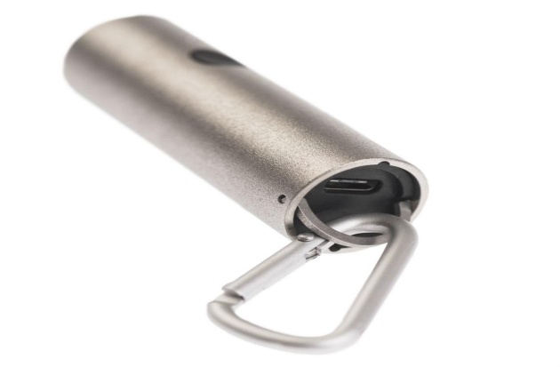

Fig. 1.1.Atmotube Atmospheric Tube [19]

After studying its characteristics, it can be noted that its advantages are:

- portability;

- the ability to view air quality on the map;

- a convenient application with graphics;

- the ability to do enough time without charging.

There are also disadvantages:

- the use of bluetooth transfer technology (4.0 LE), which when constantly connected to Atmotube affects the discharge rate of the user's battery [11];

- the use of this device is designed only for Android and IOS operating systems [10];

- relatively high price of the device.

In the comparative analysis of the device described above and the system, the development of which is devoted to this scientific work, it can be noted that the advantages of the developed system are:

- no requirements to work with any particular operating system;

- the ability to work with the device if you have access only to the search engine, to use the Telegram Web, or if you have a Telegram messenger;

- relative affordability.

Distributed in Ukraine, Xiaomi has developed a device called "Xiaomi PM 2.5 Air Detector", shown in Fig. 1.2 [18]. The abbreviation PM 2.5 in the name of the gadget is a designation of a class of small harmful solid particles that are dangerous to the human lungs. Thanks to the PM 2.5 Air Detector laser sensor, it is easy to identify these harmful elements, which can be as small as 0.3 microns.

The OLED display of the air analyzer is equipped with a special LED, which changes its color depending on the degree of purity of the air. Its parameters are as follows:

1) at a concentration of harmful solid particles in the range of 0-75 μg / m3 - the color of the indicator is green, which means normal air purity;

2) when the concentration is in the range of 75-150 μg / m3 - it is already orange, which means unsatisfactory air condition. At concentrations above 150 μg / m3, a red color is activated, which warns the owner that the air around is seriously polluted;

3) the device is also equipped with a battery with a capacity of 750 mAh, which provides up to 3 hours of continuous battery life of the gadget. PM 2.5 Air Detector is equipped with a Wi-Fi module, thanks to which it can be controlled from a smartphone.

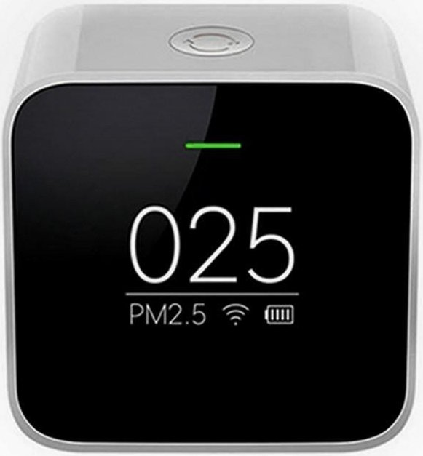Fig. 1.2. Measuring device from Xiaomi [20]

After studying its characteristics, it can be noted that its advantages are the following:

- portability;

- convenience of the application with graphics for the phone;

- the ability to do enough time without a charger.

The disadvantages include such as:

- measurement of only one parameter that affects indoor air quality;

- high price of the device;

- the inability to use the website or bot in the messenger if the user can not or does not want to install the official application on the phone.

In the comparative analysis of the device described above and the system, the development of which is devoted to this scientific work, it can be noted that the advantages of the developed system are:

- no requirements to work with anyl a certain operating system;

- the ability to work with the device if you have access only to the search engine, to use the Telegram Web, or if you have a Telegram messenger;

- relative affordability.

**SECTION 2**

SELECTION OF HARDWARE FOR PROJECT IMPLEMENTATION AND ALGORITHM OF SYSTEM OPERATION

**2.1. Scheme of system operation**

The system of the analysis of a condition of air in rooms consists of many components which continuously carry out the functions according to algorithms developed by me:

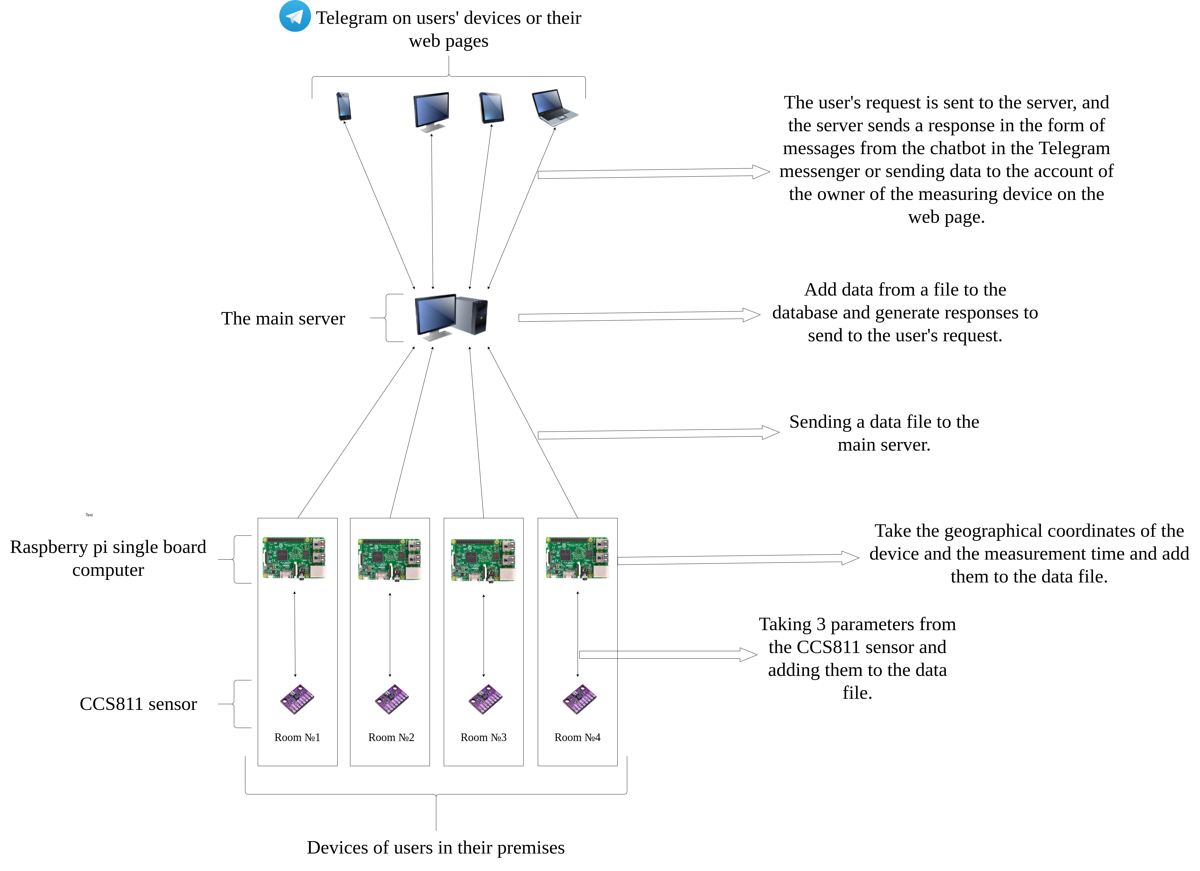Fig.2.1.Monitoring system (author's photo)

**2.2. Rationale for sensor selection**

To develop the project, I had to choose a sensor that could monitor air quality with some parameters. It turned out that in most cases uses a series of MQ sensors, which is very well distributed due to its affordable price. Manufacturer in these sensors one - the Chinese company HANWEI. After studying the HANWEI specifications, I summarized all available MQ series sensors, substrate material and detection type into a single table 2.1.

An example of a sensor from the MQ series you can see in Figure 2.2.

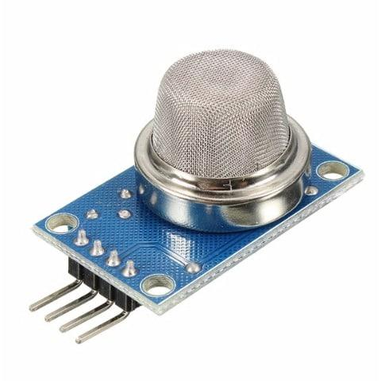

Fig. 2.2. MQ series sensor [21]

The electrochemical sensor is built on the principle of changing the resistance of one element when interacting with another element. In other words, there is a chemical reaction between these two elements, which changes the resistance of the substrate. But in order for the reaction to proceed normally and the sensor not to be disposable, the sensitive part of the sensor must be kept warm.

Pros of MQ sensors:

* affordability.

Cons of MQ sensors:

* virtually identical sensors use the same sensing element and differ in the one used face value customizable resistors;
* the lack of the declared selectivity for the measured gases, reacts to everything with carbon (and, quite possibly, to other elements that react with the substrate);
* the practical impossibility of obtaining meaningful values ​​in the form of ppm or% [4].

*Table 2.1*

**Comparison of different models of MQ series sensors**

|  |  |  |
| --- | --- | --- |
| **Sensor** | **The gas to which it reacts** | **Substrate material** |
| MQ-2 | Liquefied hydrocarbon gases | SnO2 |
| MQ-3 | Alcohol | SnO2 |
| MQ-4 | CH4 | SnO2 |
| MQ-5 | Liquefied hydrocarbon gases, natural gas | SnO2 |
| MQ-6 | Liquefied hydrocarbon gases, propane | SnO2 |
| MQ-7 | CO | SnO2 |
| MQ-9 | CH4, Liquefied hydrocarbon gases | SnO2 |
| MQ-131 | O3 | SnO2 |
| MQ-135 | Multipurpose | SnO2 |
| MQ-136 | Multipurpose | SnO2 |
| MQ-137 | Multipurpose | SnO2 |
| MQ-138 | Multipurpose | SnO2 |
| MQ-303A | Alcohol | - |
| MQ-306 | Liquefied natural gas | - |

Because of these disadvantages, we had to look for other options for sensors.

CCS811 Is a low-power digital gas sensor that integrates a metal oxide gas (MOX) sensor to detect a wide range of volatile organic compounds for the premises. Monitors air quality using a microcontroller (MCU), which includes an analog-to-digital converter (ADC) and I²C interface. CCS811 was established for the military cartographic service.

The integrated microcontroller controls the modes of the sensor driver and measurements.

The I²C digital interface greatly simplifies hardware and software design.

CCS811 supports intelligent algorithms for processing CO measurements2 and VOC.

CCS811 supports several measurement modes that have been optimized for low power consumption during active sensor measurement, and idle mode, increaseor battery life in portable devices.

Output indicators:

CO2: the range for CCS811 is from 400 ppm to 8192 ppm.

VOC: range from 0 ppb to 1187 ppb [5, p.1].

An example of the CCS811 sensor you can see in Fig. 2.3.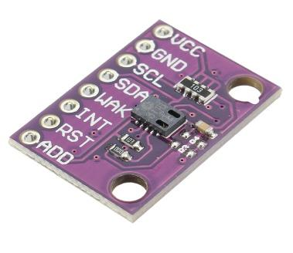

Fig. 2.3 CCS811 sensor [22]

**2.3. Justification of the choice of payment**

Arduino is a company[with software](https://en.wikipedia.org/wiki/Open-source_hardware) and [software](https://en.wikipedia.org/wiki/Open-source_software) with [open source](https://en.wikipedia.org/wiki/Open-source_hardware)m, a community of projects and users that develops and manufactures unidirectional microcontrollers and kits [microcontrollers](https://en.wikipedia.org/wiki/Microcontroller)to build digital devices. Its products are licensed for[GNU General Public License](https://en.wikipedia.org/wiki/GNU_Lesser_General_Public_License) (LGPL) or GNU General Public License (GPL)[, what](https://en.wikipedia.org/wiki/Arduino" \l "cite_note-1)allows you to produce Arduino boards and distribute the software to anyone. Arduino boards are available for sale in pre-assembled form, or as kits[do](https://en.wikipedia.org/wiki/Do-it-yourself) himself".

Board designs Arduino uses a variety of microprocessors and controllers. The boards are equipped with sets of digital and analog input pins/ output, which can be combined with various extensionsboards or mock-ups (for prototyping) and other schemes. The boards have a serial communication interface, including USB on some models, which are also used to download programs from personal computers. Microcontrollers can be programmed using languages programming C and WITH++. An example of an Arduino microcontroller you can see in Fig. 2.4.

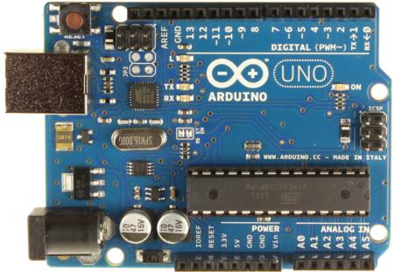

Fig. 2.4. Arduino microcontroller [23]

The Raspberry Pi is a series of small, single-board computers developed in the United Kingdom by the Pi Foundation, eto promote the teaching of basic computer science in schools. The original model became much more popular than expected,for saleoutside its target market for uses such as robotics. The Raspberry Pi Foundation offers Raspbian, a Debian-based Linux distribution for download [6].You can see an example of a Raspberry pi single board computer in Figure 2.5.

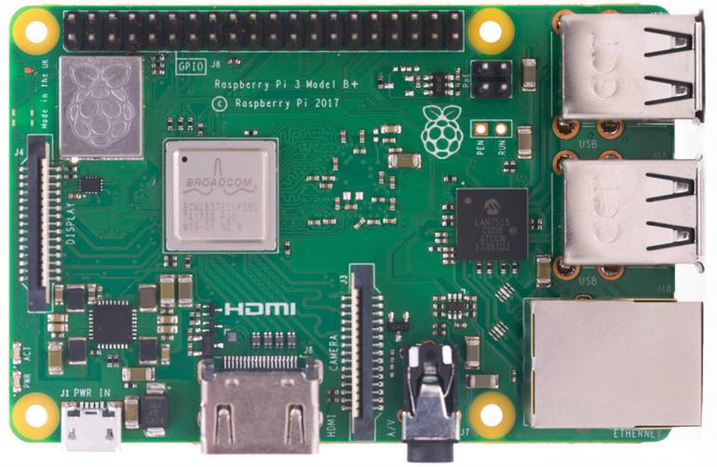

Fig. 2.5. ATRaspberry Pi Dual Computer [24]

To select the board, I chose the most important criteria and compared them in table 2.2.

*Table 2.2*

**Comparison of Arduino with Raspberry pi**

|  |  |  |
| --- | --- | --- |
|  | Microcontroller | Single board computer |
| Productivity | 1 core,  tens to hundreds of MHz,  dozens of KB of RAM,  tens to hundreds of KB of permanent memory. | 1 or more cores,  hundreds of thousands of MHz,  hundreds of MB of RAM,  gigabytes of non-volatile memory. |
| Multitasking | No. | So.  Managed by Raspbian OS. |
| Ease of working with the Internet | Additional modules and in-depth knowledge of protocols are usually required. | Easily connected from the box, the network module is usually already installed on the board. |
| Battery life | Consumes units - tens of mA. Possible weeks of battery life. | Consumes hundreds of thousands of mA. The charge of a large battery will last for ten hours. |
| Response rate in time-critical projects | 100% control over the time and duration of signals. | Because of multitasking, a critical process can fall asleep in time. |
| Choice of programming languages | Limited. Most often C / C ++. | Python, JavaScript, Bash and dozens of others: any available in the OS. |

For this project, I chose Raspberry pi, because in the algorithmic part I use sending a file with data from the sensor to the main server using SCP. SCP - transfer files via SSH, which on the Arduino would be very difficult to do, buying additional modules. Also on Raspberry pi there is a possibility of programming on python. The library for programming the CCS811 sensor from Adafruit Industries is written under this programming language.

Adafruit Industries is an open source company what operates in New York,, and was founded by Limor Frieda in 2005. The company develops, manufactures and sells a range of electronics, electronic components, tools and accessories. It also produces a number of training resources, including live and recorded videos related to electronics, technology and programming [7].

**2.4. Raspberry pi settings for indoor air analysis system**

In order for the sensor to work. you need to properly connect it to the board and configure it to work with it. To do this, followthe following step-by-step instructions:

1) You need to turn on the I2C bus so that the Raspberry pi can communicate with the sensor. To do this, open the console and enter the command: sudo raspi-config.

2) After that, you must follow the step-by-step instructions in the order shown in Fig. 2.6, 2.7, 2.8, 2.9.

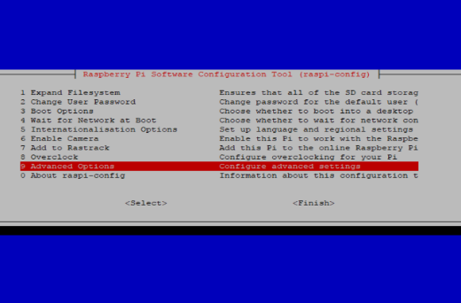

Fig. 2.6. Step-by-step instructions for setting up a Raspberry pi [25]

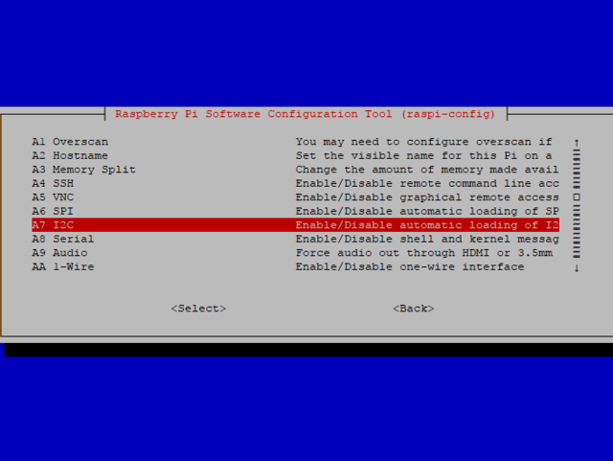

Fig. 2.7. Step-by-step instructions for setting up a Raspberry pi [26]

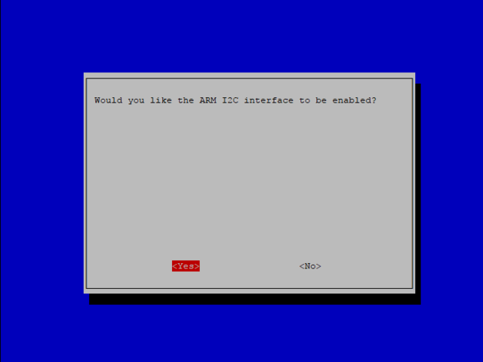

Fig. 2.8. Step-by-step instructions for setting up a Raspberry pi [27]

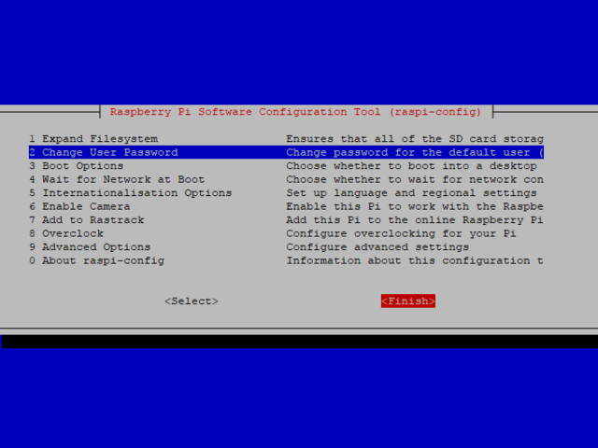

Fig. 2.9. Step-by-step instructions for setting up a Raspberry pi [28]

In order for the sensor to work properly, it is necessary to reduce the flow rate. To do this, enter the following at the command prompt:

**sudo nano / boot / config.txt**

After that, a file will open in the command line, at the end of which you need to add the line:

**dtparam = i2c\_baudrate = 10000**

Press Ctrl + X, then Y to save the changes to the file.

Now you need to unplug the Raspberry pi from the power supply to connect the sensor to it.

When Pi is disabled, we can connect the sensor to the Raspberry Pi as follows:

* connect Vin to a 3V or 5V power supply on the board;
* connect the GND to the ground pin on the board;
* connect the SDA to the sensorto SDA foam on the board;
* connect the SCL on the sensor to the foamSCL on the board;
* connect the Wake to the ground contact on the board [8].

This connection is shown in detail in Fig. 2.10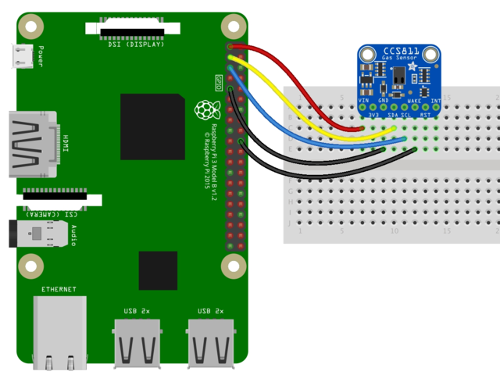.

Fig. 2.10. Sensor connection to Raspberry Pi [29]

But for programming the sensor in a programming language python must also install a special library from Adafruit Industries. To do this, write 2 commands on the command line:

**sudo apt-get update**

**sudo pip install Adafruit\_CCS811**

**2.5 Software for Raspberry pi**

The program on Raspberry pi can be divided into 4 conditional parts:

1) taking parameters from the sensor CCS811 using the library Adafruit\_CCS811;

2) taking the geographical coordinates of the device using the library using the geocoder library for the python programming language;

3) encode them in one line and write to a file on Raspberry pi;

4) transfer the data file to the server for further analysis.

Parsing each part:

1) To write a program for interaction with this sensor, you must install the program library Adafruit\_CCS811. This is done using the command you want to enter on the command line:

**pip install Adafruit\_CCS811**

After that, you just need to connect it to the program.

2) Obtaining geographical coordinates for further establishment of distance between devices in the program on the server is carried out by means of the geocoder library which is established by the command entered in a command line:

**pip install geocoder**

3) After receiving 3 parameters from the sensor: VOC, CO2, temperature, geodata and time of measurement from the device for convenience of processing of these data on the server, they need to be written down in a file through the given symbol "|". Together in the file there are lines in which the parameters of measurements are written in the following order: CO2 | VOC | temperature latitude longitude | time. You can see an example of such a file in Figure 2.11

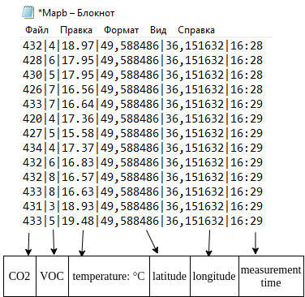Fig. 2.11. Example of a file with recorded parameters (author's photo)

4) I chose SCP to transfer the files.

SCP (from the English. Secure copy) - a utility and copy protocol, in contrast to the utility RCP, as a transport is not RSH, and encrypted SSH. A functionally similar utility is sftp.

In UNIX-like operating systems of the same name (scp) a remote file copying utility is often part of the openssh package [9].

Raspberry pi sends the file as in fig. 2.12, to the server every minute.

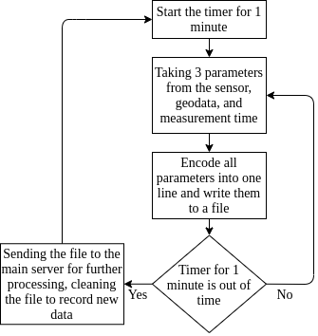

Fig. 2.12. Flowchart of the Raspberry Pi (author's photo)

**2.6. Software on the main server**

The program on the main server is much more complicated than on Raspberry pi and consists of 3 large blocks:

1) Algorithm for decoding a file to extract parameters from it, as well as their entry in a common database. The device id, 3 measurement parameters and geographical coordinates of the device are added to the database.

Because the sensor is too sensitive, I decided to average all the values ​​obtained from the file. After that, these values ​​are analyzed to compile a report and then send to the user, as in Fig. 3.1.

2) A bot in the Telegram messenger called "Air Pollution Monitoring Bot" (APMB) with which the user communicates.

3) A website where a user can register to communicate with the device if he is not able to use the bot in Telegram.

**2.7. Telegram bot development**

To start working with the bot you need to send him a command:

**/ start**

After that, 6 buttons appear: "information", "monitoring", "latest data", "complete testing", "statistics", "nearest devices". An example of a panel with buttons is shown in Fig. 3.3.

Functions for which each of the buttons is responsible:

1) when pressing the "information" button, the bot sends a response about the impact on the human body of CO2 and VOC at their concentration above the permissible level;

2) the "monitoring" button activates the process of notification from the 1st block of the user about the state of the air with the set frequency every 10 minutes;

3) the button "latest data" sends from the 1st block to the user the latest report on a condition of air. An example of such a message is shown in Figure 3.1;

4) the "stop monitoring" button interrupts the process of sending notifications to the user;

5) the button "statistics" sends the data issued by the algorithm from the point for the period of time specified by the user after pressing the button, as in Fig. 3.2;

The block diagram of the program on the main server is shown in Fig. 2.13.

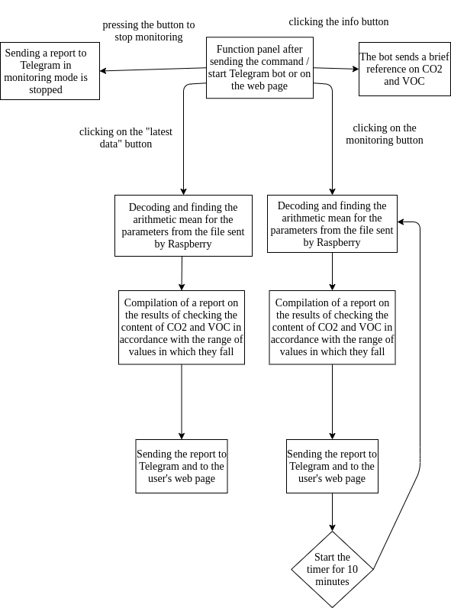6) the button "nearest devices" sends to the user the last measurements from devices of other persons which are in the range specified by the user after pressing this button.

Fig. 2.13. Block diagram of the Telegram bot program (author's photo)

**2.8. Development of a WEB-page for interaction with the user**

The site consists of 4 pages: “Devices ”,“ Info ”,“ Login ”,“ Register ”.

Functions for which each of the pages is responsible:

1) page “Devices” is the main page of the site, where convenient cards are located, an example of one of them is shown in Fig. 2.15 with the number of the measuring device and 2 main parameters VOC and CO2. In order to see other parameters and statistics, you need to click on the "More statistic" button. You can also turn off the device or change the frequency of updates from standard to your room using the "Settings" button;

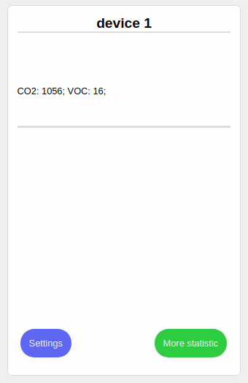Fig. 2.15. Example of a card of one of the devices (author's photo)

2) page “Info” is a page where the user can read about the project;

3) page "Login" allows the user to log in to see data from their devices;

4) page “Register” is a page for registering an account in the system. You can only use the web page when registering in the system.

To develop the site, I used a technology called MERN [15].

It stands for MongoDB, Express.js, React.js, Node.js, where:

1) MongoDB: JSON documents created in your React.js interface can be sent to the Express.js server for processing and (provided they are valid) stored directly in MongoDB for further retrieval.

2) Express.js: works inside the Node.js server. Express.js calls itself "a fast, impenetrable, minimalist web environment for Node.js," and that's really what it is. Express.js has powerful models for routing URLs (matching the inbound URL with the server function) and processing HTTP requests and responses.

You can connect to the Express.js features that power your program by making HTTP (XHR) or GET or POST XML requests from your React.js interface. These features, in turn, use the Node.js, MongoDB drivers, or through callbacks to use Promises, to access and update data in your MongoDB database.

3) React.js: кThe MERN stack component is React.js, a declarative JavaScript framework for creating dynamic client-side applications in HTML. React allows you to create complex interfaces with simple components, connect them to data on your server and display them as HTML.

The strength of React is the processing of data-driven interfaces with minimal code and minimal pain, and it has all the impressive features you would expect from a modern web structure: excellent form support, error handling, events, lists, and more.

4) Node.js:itan open source platform for high-performance networking applications written in the language JavaScript. The founder of the platform is Ryan Dahl. If before JavaScriptused to process data in the user's browser, then Node.js provided the ability to run JavaScript scripts on the server and send the user the result of their execution. The Node.js platform has turned JavaScript into a common language with a large community of developers.

The MERN architecture makes it easy to build a three-tier architecture (interface, server, database) using JavaScript and JSON. The interaction of the stack components is shown in Fig. 2.14 [15].

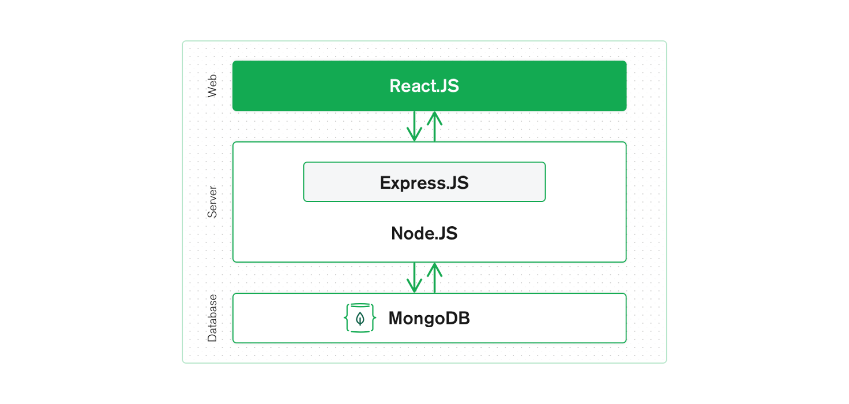

Fig. 2.14. MERN Stack Component Interaction Diagram [30]

**2.9. Strategy of frequency of data collection from the sensor and their subsequent sending to the user**

To select the frequency of data collection from the sensor and send them to the user, it was necessary to consider the following parameters:

1. the amount of CO2, which allocates one person per unit time;
2. the number of people who can be in the room.

This is necessary in order not to consume excess electricity, for example, if the device is connected to an uninterruptible power supply.

One person exhales from 18 to 25 liters of carbon dioxide within an hour, consuming 20-30 liters of oxygen.

If a person is in a room of 20 m2 with a ceiling height of 2.5 m and poor ventilation, the level of CO2will increase by 580 ppm every hour. Therefore, even a perfectly ventilated room will become a source of headache in an hour, and after 8 hours the concentration of CO in it2will approach a critical level. If there is more than one person in the room, the speed of production СО2 will increase accordingly [16].

As an example, consider a closed classroom with 25 students and a teacher. In an hour and a half, 26 people exhale 0.78 m3 of carbon dioxide into the auditorium (0.02 m3 / h per 1 person). The volume of the audience will be taken, for example, equal to 280 m3. As a percentage, calculate the volume of air replaced by CO gas2- 0.2786%, which is the number of parts per million 2786 ppm. At this level there is already a decline in strength and poor performance [17].

On the basis of calculations it is optimal to carry out measurementdata sensor with an interval of one minute for a more accurate average value sent to the user. More frequent number of measurements is not necessary and is excluded due to energy consumption. The frequency of data sending is selected with an interval of 15 minutes, which allows you to not miss the moment of informing the user with a possible increase in CO2 and VOC above the allowable.

**SECTION 3**

**EXAMPLES OF USING THE SYSTEM**

**3.1. Example of Telegram-bot operation**

In this section I demonstrate screenshots of the system and the interface used by the user:

1) Figure 3.1 shows the menu of commands in Telegram, with which the user commands the bot.

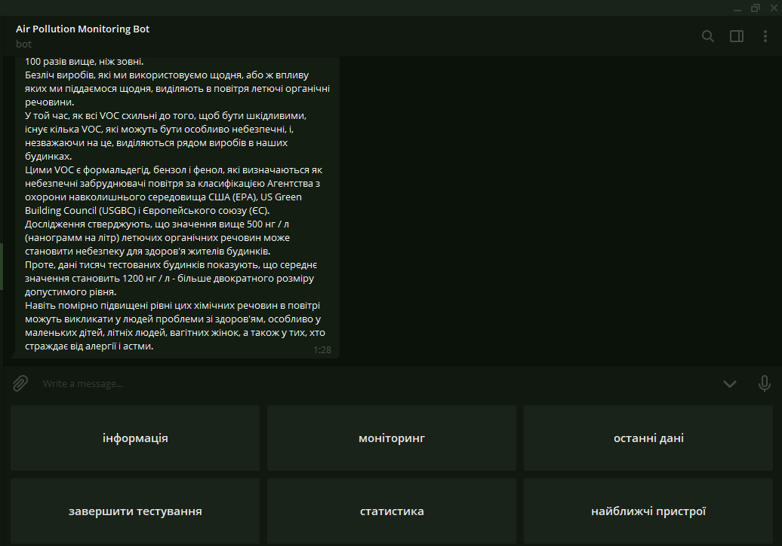

Fig. 3.1. Example of the main control panel (author's photo)

2) In Fig. 3.2 shows the response of the bot to the command "latest data" in the format.This message contains 3 measurements of VOC, CO2 and temperatures with textual explanations of the impact of such indicators.

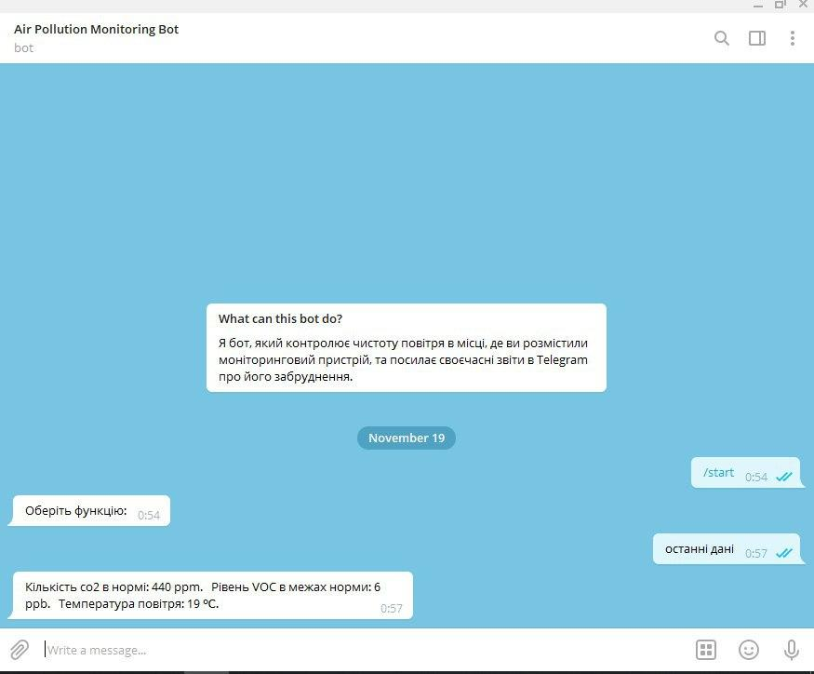

Fig. 3.2. Example of an air condition report (author's photo)

3) In Fig. 3.3 shows the response of the bot to the command "statistics", which indicates the maximum and minimum values ​​of all parameters: CO2, VOC and room temperature for a period of time specified by the user.

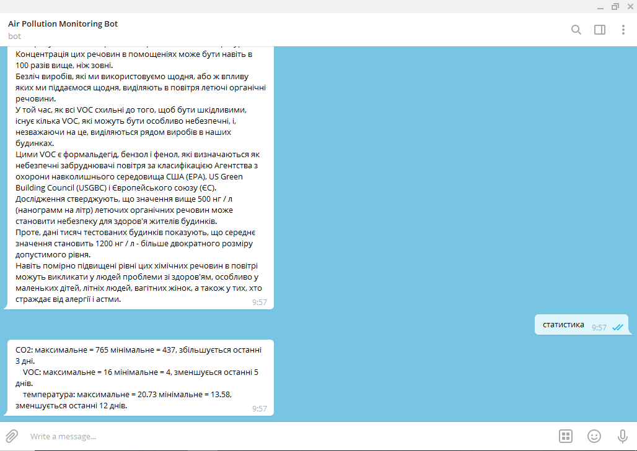

Fig. 3.3 Example of a statistical data collection algorithm report (author's photo)

**3.2. Example of WEB-page operation**

1) In Fig. 3.4 shows the main page of the website with device cards, with which you can control the measuring devices using the "Settings" button, and view the data using the "More statistic" button.

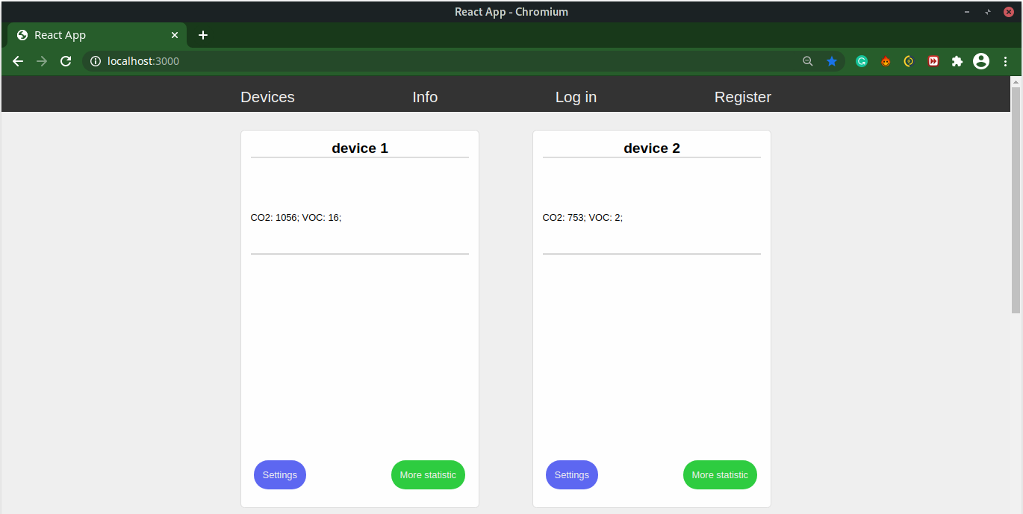

Fig. 3.4. View of the main page of the WEB-site (author's photo)

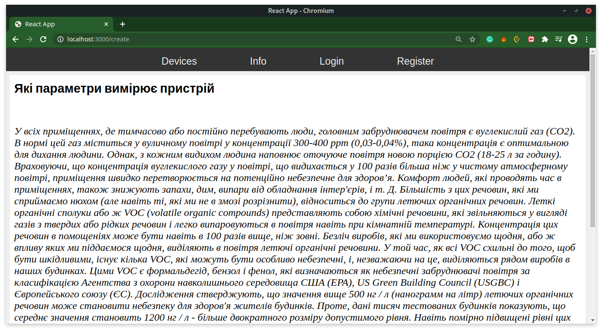2) In Fig. 3.5 shows the appearance of the page "Info", a link to which is on the top control panel. This page contains information about the usefulness of the developed system and the impact of the substances it measures on human health.

Fig. 3.5. Info page view (author's photo)

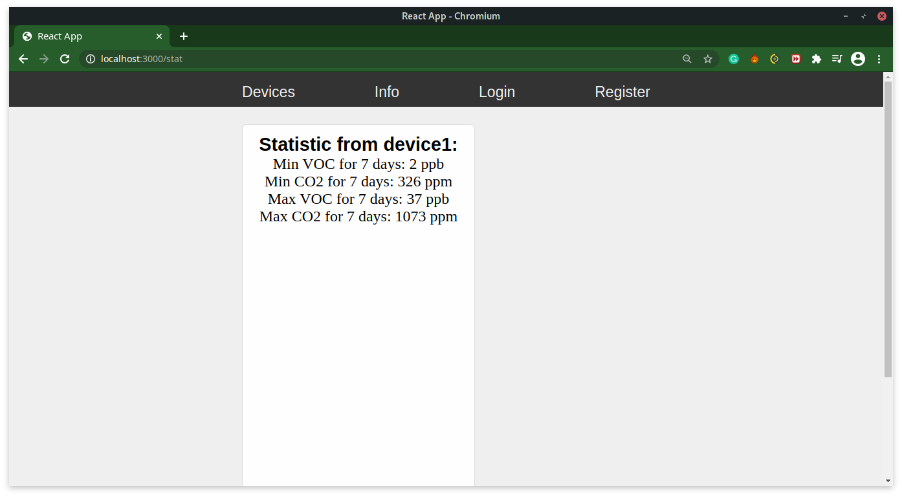3) In Fig. 3.6 shows the appearance of the page "More statistic", a link to which is located on the card of the device. It indicates the maximum and minimum CO values2 and VOC for the period of time specified by the user on the other “Settings” page (the default interval is 1 week).

Fig. 3.6. Page view “More statistic” (author's photo)

4) When you click on the "Settings" button on the device card, the site sends you to the page with the settings of this device (Fig. 3.7). This page consists of the following components:

* texts field “Interval for collecting statistics”It is necessary for the user to enter a number in minutes, which will affect the interval of analysis of statistical data, ie if the user specified, for example, 2 weeks, the section" More Statistic "of this device will indicate the maximum and minimum CO2 and VOC in exactly 2 weeks;
* text box "Data refresh rate from server to user”Is used by the user to write the time interval in minutes, after which the air quality parameters on the site will be updated;
* text box "Data refresh rate from device to server ”is designed to set the time in minutes, which affects the frequency of sending new data from the device to the server;
* the “Reboot” button is designed to restart the measuring device, for example if it has stopped updating data;
* Shutdown button (device name) is designed to turn off the measuring device if the user wants to turn off the device;
* the “Apply” button is designed to save new settings. Also, after clicking on it, the user gets to the main page.

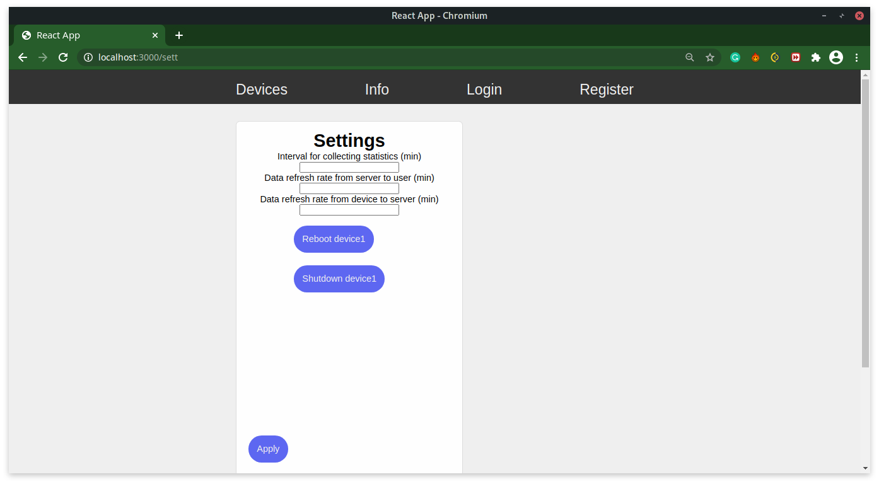

Fig. 3.7. Example page for customization (author's photo)

**CONCLUSIONS**

1. Currently, the development of air quality measuring devices, which would allow users to receive information at any time convenient for them, is becoming increasingly important.

2. A detailed review of existing projects and individual air quality monitoring systems revealed that they have not yet become widespread in Ukraine and that the need for information on air quality, especially indoors, is not satisfactory.

3. To develop an air quality monitoring system, the optimal CCS811 sensor, which supports intelligent algorithms for processing CO measurements, was analyzed and selected.2 and VOC, as well as the Raspberry pi board.

4. The software was written in the Python programming language.

5. As a result of this work, a software and hardware complex was developed that allows to obtain and process air quality data at any point of geolocation, with subsequent transmission of the result to the end user using a bot in the messenger - Telegram or user web pages.

**REFERENCES**

**INTERNET RESOURCES**

1. TSN. The article "CO2 levels in the atmosphere have reached unprecedented levels. What does this mean for the planet and human health." URL:

https://tsn.ua/ru/svit/uroven-co2-v-atmosfere-dostig-nevidannoy-v-istorii-otmetki-chto-eto-oznachaet-dlya-planety-i-zdorovya-lyudey-1345605.html

2. UA League News. Article "Ukraine in a cloud of black air". How to monitor CO2 and monitor the situation. "URL:

https://ua-news.liga.net/society/articles/ukraina-v-hmari-chornogo-povitrya-yak-monitoriti-pokazniki-so2-i-stejiti-za-situatsieyu

3. Official site of the Czech manufacturer of sensors Protronix. Article "Measuring CO2 is often insufficient". URL:

https://www.careforair.eu/ru/merit-co2-casto-nestaci-ru/

4. Sparkfan. Documentation for CCS811 sensor. URL:

https://cdn.sparkfun.com/assets/learn\_tutorials/1/4/3/CCS811\_Datasheet-DS000459.pdf

5. [Многобукффф](https://blog.kvv213.com/). Article "Dealing with CO and methane sensors MQ-4 and MQ-7". URL:

https://blog.kvv213.com/2016/09/razbiraemsya-s-datchikami-co-i-metana-mq-4-i-mq-7/

6. Wikipedia. Article "Raspberry Pi" .URL:

https://en.wikipedia.org/wiki/Raspberry\_Pi

7. Wikipedia. Article "Adafruit Industries". URL:

https://en.wikipedia.org/wiki/Adafruit\_Industries

8. Adafruit. Article "Adafruit CCS811 Air Quality Sensor". URL:

https://learn.adafruit.com/adafruit-ccs811-air-quality-sensor/raspberry-pi-wiring-test

9. Wikipedia. Article "SCP". URL:

https://ru.wikipedia.org/wiki/SCP

10. Official site of the manufacturer Atmotube. URL:<https://atmotube.com/?view=ru>

11. Habr. Article "Atmospheric tube Atmotube - a portable air quality sensor". URL:

<https://habr.com/ru/company/dadget/blog/404389/>

12. New York Times. Article "Do You Know What You're Breathing?" URL:https://www.nytimes.com/2018/11/30/style/air-quality-pollution-monitors.html

13. UA League News. Article "Ukraine in a cloud of black air". How to monitor CO2 and monitor the situation. "URL:

https://ua-news.liga.net/society/articles/ukraina-v-hmari-chornogo-povitrya-yak-monitoriti-pokazniki-so2-i-stejiti-za-situatsieyu

14. Wikipedia. Article "Arduino". URL:

https://en.wikipedia.org/wiki/Arduino

15. Mongo DB. Article "What is the MERN Stack?". URL:

https://www.mongodb.com/mern-stack

16. Official site of the manufacturer of Vairgeo sensors. Article "Control of ventilation by CO2 level". URL:

[http: //www.wiregeo.com/solutions/25/](http://www.wiregeo.com/solutions/25/)

17. Storeint. Article "The content of carbon dioxide in the room is the norm". URL:

http://storeint.ru/soderzhanie-uglekislogo-gaza-v-pomeschenii-norma/

18. Myot. Article "Review: Xiaomi PM 2.5 Air Detector - a sensor that will not leave any chance for dirty air to escape!". URL:

https://miot.ua/news-and-actions/oglyad-xiaomi-pm-25-air-detector-sensor-yakiy-ne-zalishit-brudnomu-povitru-jodnogo-shansu-vtekti/

19. Atmospheric tube Atmotube. URL:

https://images.satu.kz/156219705\_w640\_h640\_portativnyj-monitor-kachestva.jpg

20. Measuring device from Xiaomi. URL:

https://wo.ua/upload/iblock/4a2/4a21133e11d77794159c76857374b3ed.jpg

21. MQ series sensor. URL:

https://buddyelectronics.com/wp-content/uploads/2020/11/cdds-300x269.png

22. CCS811 sensor. URL: https://opencircuit.shop/resources/content/ZJN5Y3K4M5DXRKHK6ASW/crop/900-600/Luchtkwaliteit.-temperatuur-en-luchtvochtigheids-sensor-CCS811-HDC1080.jpg

23. Arduino microcontroller. URL: https://media.springernature.com/original/springer-static/image/chp%3A10.1007%2F978-981-15-0199-9\_39/MediaObjects/481382\_1\_En\_39\_Fige\_HTML.png

24. Оraspberry pi computer. URL: https://pisces.bbystatic.com/image2/BestBuy\_US/images/products/6339/6339655\_sd.jpg

25. Step-by-step instructions for setting up Raspberry pi. URL:

https://cdn-learn.adafruit.com/assets/assets/000/047/803/thumb160/sensors\_Screenshot\_%2821%29.png?1509568345

26. Step-by-step instructions for setting up Raspberry pi. URL:

https://cdn-learn.adafruit.com/assets/assets/000/047/804/thumb160/sensors\_Screenshot\_%2822%29.png?1509568357

27. Step-by-step instructions for setting up Raspberry pi. URL:

https://cdn-learn.adafruit.com/assets/assets/000/047/806/thumb160/sensors\_Screenshot\_%2823%29.png?1509568411

28. Step-by-step instructions for setting up Raspberry pi. URL:

https://cdn-learn.adafruit.com/assets/assets/000/047/807/thumb160/sensors\_Screenshot\_%2824%29.png?1509568423

29.Connecting the sensor to the Raspberry Pi. URL:

https://cdn-learn.adafruit.com/assets/assets/000/098/293/medium640/adafruit\_products\_raspi\_ccs811\_i2c\_bb.jpg?1609367757

30. Scheme of interaction of MERN stack components. URL: https://webassets.mongodb.com/\_com\_assets/cms/mern-stack-b9q1kbudz0.png